SEXUAL HARASSMENT ANNUAL REPORT

In compliance with La. R. S. 42:344, this report contains information for calendar year 2022 Regarding sexual harassment in the workplace.

- The number of employees at the West Baton Rouge Convention and Visitors Bureau who completed the sexual harassment training requirements found in La. R. S. 42:343 during 2021 is seven (6).

- The number above represents 100% of the employees for the West Baton Rouge Convention and Visitors Bureau.

- During 2022, the West Baton Rouge Convention and Visitors Bureau received zero (0) complaints of sexual harassment.

- Of the complaints enumerated above, zero (0) resulted in a finding that sexual harassment had occurred.

- Of the complaints enumerated above, the finding of sexual harassment resulted in discipline or corrective action zero (0) times.

- Here is a listing of the time that it took to resolve each received complaint of sexual harassment:

Claims: None - No time was needed.

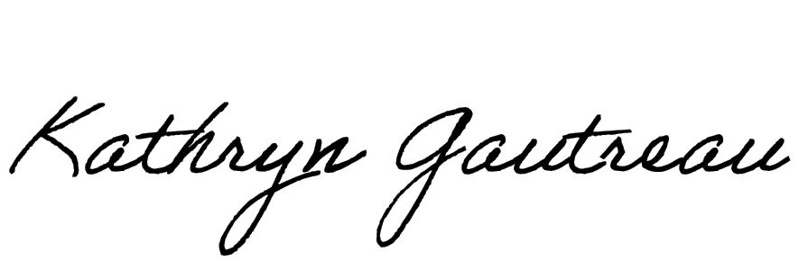
January 10, 2022 _____________________
Executive Director
West Baton Rouge CVB

